

Final Project of SYSADD

Predictive Analytics

Submitted by:  
Sy, Davvid Paulo L.

Colinares, John raylanne O.

Landig, Maria Chrisva C.

Salazar, Ma. Aurora G.

Ysulan, Lorenz

Table of Contents

I. Introduction

1.1 Project Context…………………………………………………………………….……………………………………………….3

1.2 Purpose and Description……………………………………………………………………………….………………………3

1.3 Objectives…………………………………………………………………………………………………………………………….4

1.4 Scope and Limitations…………………………………………………………………………………….…………………….4

II.Related Literature

2.1 Predictive Analytics………………………………………………………………………………….……………………………5

2.2 Hotel and Convention Corporation………………………………………………………………………….……………7

2.3 Data Mining………………………………………………………………………………………………………………….………8

III. Design and Methodology

3.1 Use Case diagram………………………………………………………………………………………………………………….9

3.2 State Diagram……………………………………………………………………………………………………………….…….10

3.3.1 Activity Diagram – Managing Survey Form………………………………………………………………….…..10

3.3.2 Activity Diagram – Managing Data…………………………………………………………………...………….….11

3.3.3 Activity Diagram – Managing Access…………………………………………………………………….………….11

3.4 Class Diagram……………………………………………………………………………………………………………….…….12

3.5 Deployment Diagram……………………………………………………………………………………………………….…12

3.6 Object Diagram………………………………………………………………………………………………………….……….13

3.7 Use Case Package Diagram………………………………………………………………………………………………….13

3.8 Component Diagram……………………………………………………………………………………………………….….14

3.9 Sequence Diagram……………………………………………………………………………………………………….….….15

3.10 Communication Diagram…………………….…………………………………………………………………………….16

3.11 Composite Diagram……………………………………………………………………….………………………………….17

3.12 Timing Diagram………………………………………………………………………………………………………………...17

3.13 Interaction Diagram………………………………………………………………………………………………………….18

3.14 Use case Full Description…………………………………………………………………...…………………………....19

IV. References …………………………………………………………………...………………………….........................................25

I. Introduction

1.1 Project Context

This project is about developing a Predictive Analytic System for SM Hotel and Convention (SMHC), for currently they don’t have one, but they do have several reports that they rely on for manager’s decision making, which are in their database called Opera (product of Oracle). The team aims to provide a competitive advantage to SMHC against competitor when the system is used. With the use of Predictive Analytics, the group aims SMHC to have a better operation, more efficient and effective services. Trend Reports is what SMHC use to base if there is a need for an increase or decrease of employees on the upcoming months. If ever they decreased the number of their employees, it might affect the efficiency and effectiveness of their service which is bad for the reputation of the organization because what represents the organization is the employees.

1.2 Purpose and Description

In some industries employees represents the company, and this phrase includes the hotel industry. Employees of hotel are mostly the front-line of the organization, they are the one who interacts with the guest, which means if guest were displeasured then it heavily affects the organization, and do take note that hotel industry is continually growing, a dissatisfied customer can easily find another hotel if one gave a bad impression during his/her stay. This is where survey comes in and those data are weightily important to the hotel to react on what changes needs to be done. We believe that SM Hotels and Conventions has the necessary reports to know the situation, but with those tons of reports it will take a time for a man to come up with an analysis on what to do. So the Predictive Analytics we aim to develop would not only save time for the employee but also give meaningful outputs for manger for their decision making. Not only did they save time and energy of their employees but also got them a better report on what to do on the upcoming day, month and year; therefore, it is a win-win situation.

1.3 Objectives

### 

### Main Objective

The project aims to develop an automated Predictive Analytics system for SM Hotels and Conventions that would retain a great level of efficient and effective service of their organization.

### Specific Objectives

* To analyze the survey results and base there to come up with suggestions on what should be retained and changed, so that managers can have a clearer picture on what aspect to improve
* To provide the decision makers a report monthly and yearly basis
* To be able to dig deeper on the complains of the guest

1.4 Scope and Limitations

The study is about creating a predictive analytics system for SM Hotels and Conventions. Users are able to read the reports as long as system administrator have registered them in the system. The focus would be the employee performance, on what to retain to keep the efficiency and effectiveness of the normal operation of the company, we base this from the survey results. Anything about income and expense of the organization are considered insignificant for survey results is our basis and this does not contain income and expense. Output should be able to suggest a solution for the complains and to be able to tell the cause of those complain. Reports are submitted on monthly basis.

## II. Related Literature

## 2.1 Predictive Analytics

According to Marvin (2016), Predictive analytics is not a straightforward concept or a distinct feature of model database managers. It is a group of data analysis technologies and statistical techniques rolled up below one banner. Regression analysis is the core technique which predicts the like values of multiple, correlated variable based on showing or not showing of a particular assumption. Predictive analytics is all about identifying patterns in data to project probability, stated by Allison Snow a Senior Analyst of B2B Marketing at Forrester.

In addition, Present’s reality are less futuristic robots or automating every single marketing workflow. There’s a bunch of intelligence that predictive analytics and machine language brought to the work of answering these questions and that is the root wherein AI is bringing value today. Positive thinking enterprise sales teams are reserving lots of time by simply using predictive solutions to enhance the way they screen and prioritize inbound leads. Companies with the “champagne” problem of a huge volume of entering prospects are using predictive analytics and AI to automatically research leads who looks like customer of the company (Zinsmeister, 2017).

Predictive Analytics (PA) is not something that is new or was just invented, in fact, according to Eric Siegel this existed and was used as early as World War II. The Father of "Cybernatics", also known as Norbert Weiner tried to predict the behavior of German airplane pilots in 1940 and had a goal of shooting them from the sky. The data he used was the trajectory of plane base on observation, the most likely evasive maneuvers of the pilot and where the will be position of the plane in after the maneuver, so when a shell is fired it has a either a hit or a higher percentage of hitting. The whole point of this is discussed is how useful PA is, but we want to use PA in Hotel Industry, if used, should be able to help the performance of the hotel.

As said by Marco Benvenuti, Co-Founder/Chief Analytics & Product Officer, Duetto Research (2015), Start looking at what people came to your website for and when? What, when and where they were looking to purchase – and then what did they do? Did they book or not? The information on the people that did not book is as important as the information of those that did book – that gives you a complete picture.

Predictive Analytics defined by Nishchol Mishra and Dr.Sanjay Silikari / (IJCSIT) International Journal of Computer Science and Information Technologies (2012) which predictive analytics deals with prediction of the future events based on the historical data by applying sophisticated/statistical methods like machine learning, predictive modeling and data mining which use for computational techniques from statistics and pattern recognition. Base on the journal the historical data that was gathered or collected and transform by using various technique like filtering, correlating and etc. Predictive Analytics used to determine the probable outcome in the future of an event also predictive analytics used to analyze large amount of data with different variables like clustering, decision tree, genetic algorithms, regression modeling and more.

According to Kevin Bonnes Predictive analytics is a group of methods that uses statistical and other empirical techniques to predict future events, based on past occurrences. Although predictive analytics has become a hot topic recently, there are many companies within the supply chain sector that don't make use of it yet.

As literature states, enhancing effectiveness and efficiency of supply chain analytics is a critical component of a company's ability to achieve competitive advantage. Predictive analytics for supply chains is therefore an interesting topic.

Predictive analytics are used in many different fields. This research focuses on the supply chain sector. An example of the use of predictive analytics in the supply chain is predicting the arrival times of a truck or a ship. There are multiple variables that can influence arrival times, for example: the weather, traffic congestion and the driver's driving style.

If the reliability of predicting arrival times can be increased, costs can be saved within the entire supply chain. These costs can be found in waiting times for trucks in distribution centers and improved decision-making. If companies get a better understanding of how predictive analytics should be used, decision-making at management level will be improved.

Currently there is literature available on this research area, but there is no overview. This research will provide this overview by mapping out all of the relevant information available by conducting a systematic literature review, as described by Webster & Watson. Afterwards, the literature will be categorized and presented in terms of models, methods, techniques and applications. We will also show the current trends in predictive analytics for the supply chain, to see where the field is going.

As of 2015, R.Dale Hall, a managing Director of Research in Society f Actuaries defined the predictive analytics that it’s a process of using modeling and data analysis techniques on large data sets to discover predictive patterns and relationships for business use. And also He said that despite of many different types of companies and practice areas, the predictive models have to emerged to help guide in business decisions and opportunities. Predictive analytics techniques have help a quick development far beyond the well-known examples of technology-dependent business model like amazon and Netflix. R.Dale Hall says that “more than ever, it has been financial services firms, healthcare providers and all levels of government agencies getting into the predictive analytics mix.”

The Research of Society of Actuaries¬ team have selected examples of predictive analytics from a recent Call for Articles issued by Society Actuaries. Those articles give insights on the largening scale of ways that the actuarial profession is using these kinds of method in affecting business decision. These example demonstrates the expanding ways that actuaries are putting predictive modeling techniques into practices.

One of their research about is “Predicting Emergency Room Frequent Flyers”. The Predictive modeling that can help them to identify the people who are more likely to use the emergency room many times a year. The patients are referred as “Frequent flyers”. The patient or so called frequent flyers is defined as three or more ER visits per year.

## 2.2 Hotel and Conventions Corporation

Online hotel reservations are becoming a very popular method for booking hotel rooms. Travelers can book rooms from home by using online security to protect their privacy and financial information and by using several online travel agents to compare prices and facilities at different hotels. People can book directly on an individual hotel’s website. An increasing number of hotels are building their own websites to allow them to market their hotels directly to consumers. Non-franchise chain hotels require a “booking engine” application to be attached to their website to permit people to book rooms in real time. One advantage of booking with the hotel directly is the use of the hotel’s full cancellation policy as well as not needing a deposit in most situations.

Hotel industry is another industry where effective use of analytics can change dramatically how business is run. Hoteliers capture loyalty information, for example, but few go beyond loyalty tier in how they consistently view and take action with their guests. With analytical exploitation of their data, hoteliers can go beyond their traditional loyalty programs and deepen their knowledge of guests in order to develop a more granular understanding of segment behavior, needs, and expectations; identify profitable customer segments and their buying preferences; and identify opportunities to attract new guests. But all that starts with having clear customer-driven vision, before embarking on Integrating and standardizing guest data from multiple channels, systems and properties into a unified, accurate view of all interactions.

According to Taal Vista Hotel they make available to the best guest room price for the hotel. Taal Vista Hotel Website" is the websites owned or operated by or on behalf of Taal Vista Hotel bearing the logo and branding of Taal Vista Hotel. In the unlikely event that a lower price at Taal Vista Hotel is made available on a non-Taal Vista Hotel website, upon its receipt of a claim that satisfies these Best Price Guarantee terms and conditions the "BPG Terms".

According to Lailani (2017) Pros- cool weather, place near every must-go places in Tagaytay, taal lake view, friendly staff, clean place, view at the mountain wing Cons- room's a bit old and not sound proof-you'll hear the noise from the hallway, pool not heated-my kid loves swimming but unable to swim because of the cool weather, Veranda always full during breakfast but good thing they have other rooms available like the lounge and at the Taza resto.

## 2.3 Data Mining

Data mining is the method of defining the useful information from the large amount of data. The interesting patterns can be mined with the help of the several data mining techniques. These are the several major data mining techniques for developing and using in data mining projects, the association, classification, clustering, prediction, sequential patterns and decision tree. Sequential patterns analysis try to pursue or recognize related patterns, usual events or trends in transaction data for a business period. It is easy to recognize a set of items that customers buy together in a year. This information will have led the businesses to recommend customers deal with the better agreement based on their purchasing frequency in the past.

So, in our project, sequential patterns analysis will help us in the trends of the hotel. For example, when it’s a peak season for the hotels, early March to early June and early December to early February, the hotel will have a huge number of guests and it will be lessening and lesser when off peak.

## III. Design and Methodology

**3.1 Use Case Diagram**

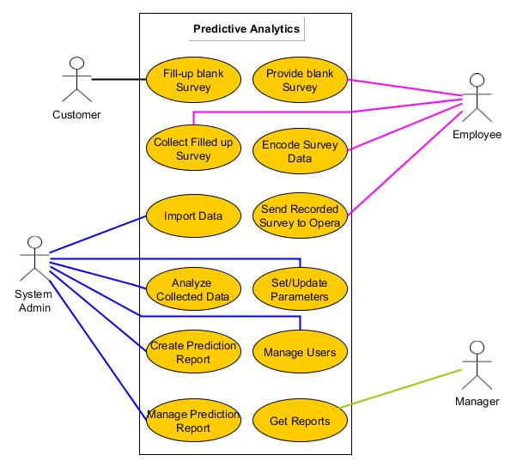

**3.2 State Diagram**

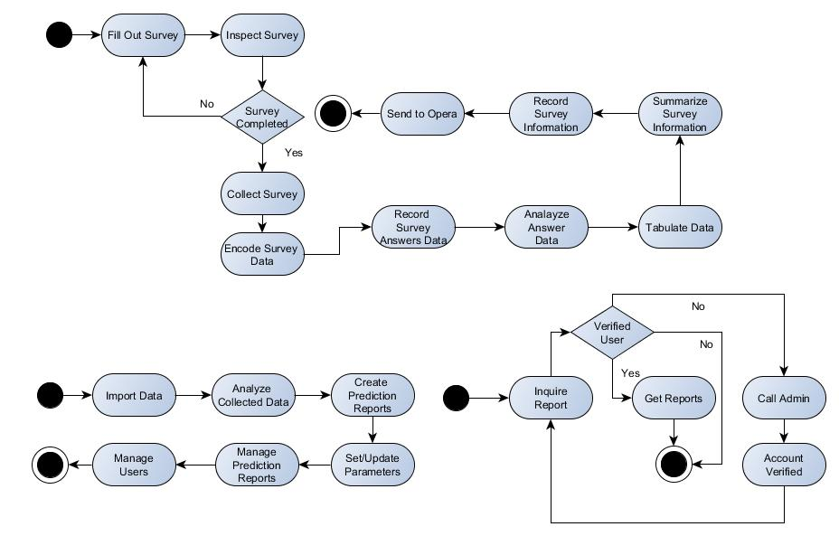

**3.3 Activity Diagram - Managing Survey Form**

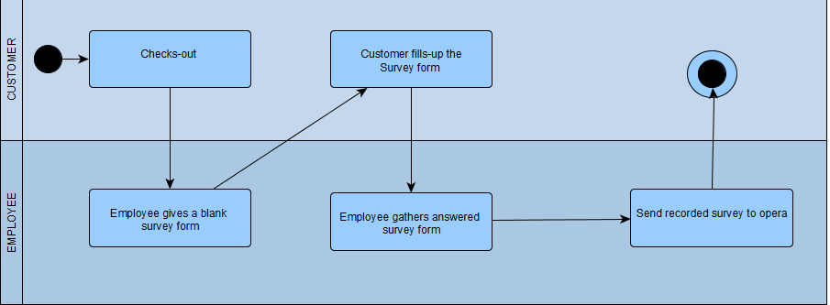

**3.3 Activity Diagram - Managing Data**

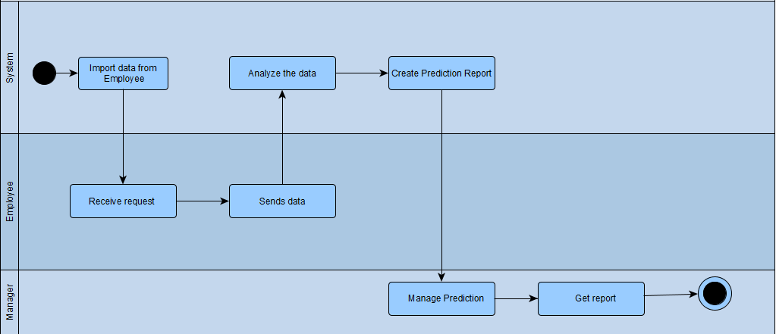

**3.3 Activity Diagram - Managing Access**

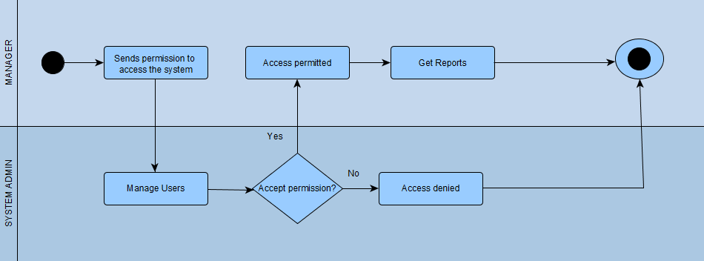

**3.4 Class Diagram**

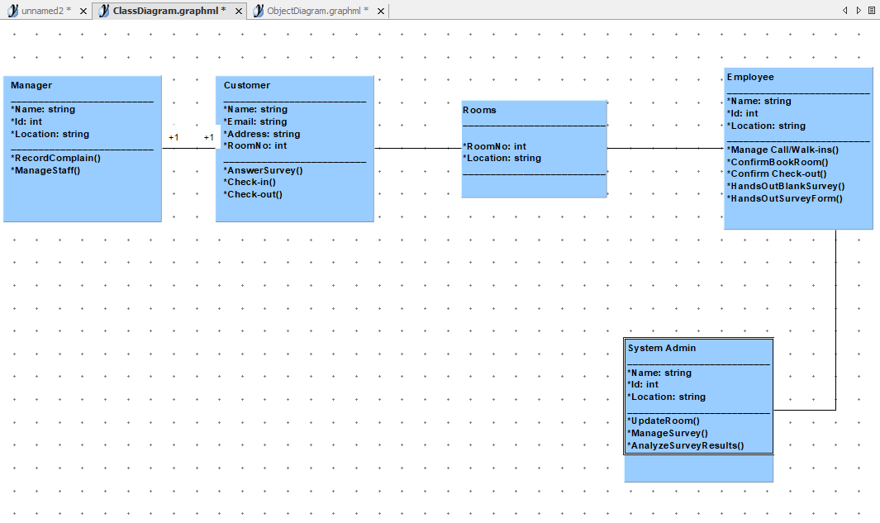

**3.5 Deployment Diagram**

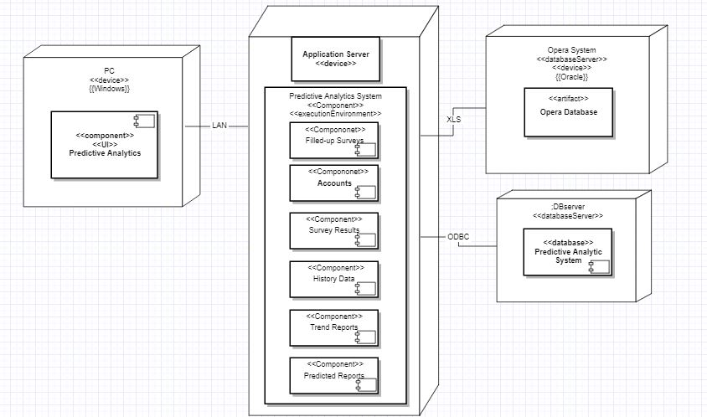

**3.6 Object Diagram**

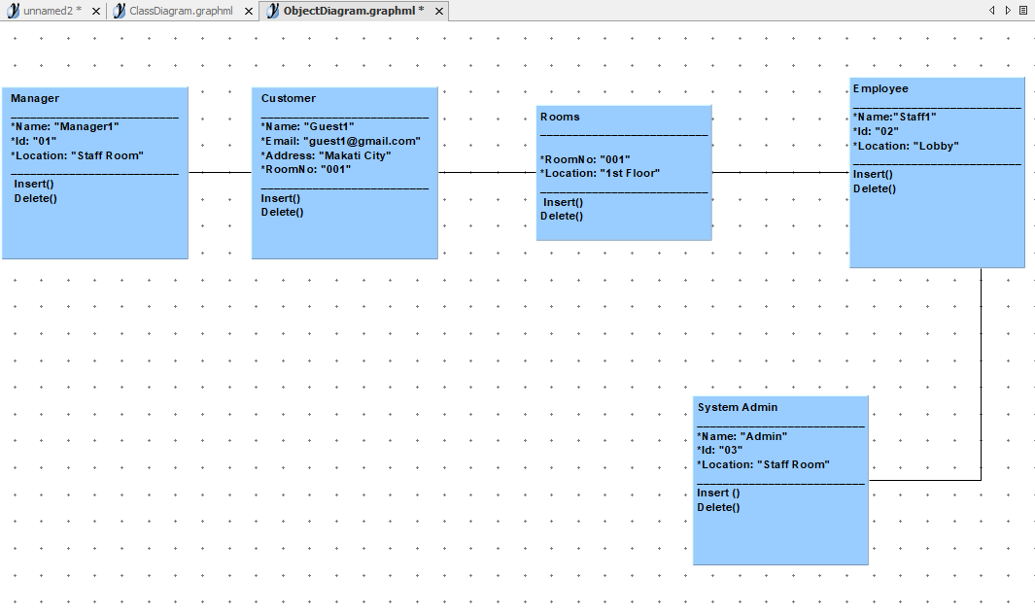

**3.7 Use Case Package Diagram**

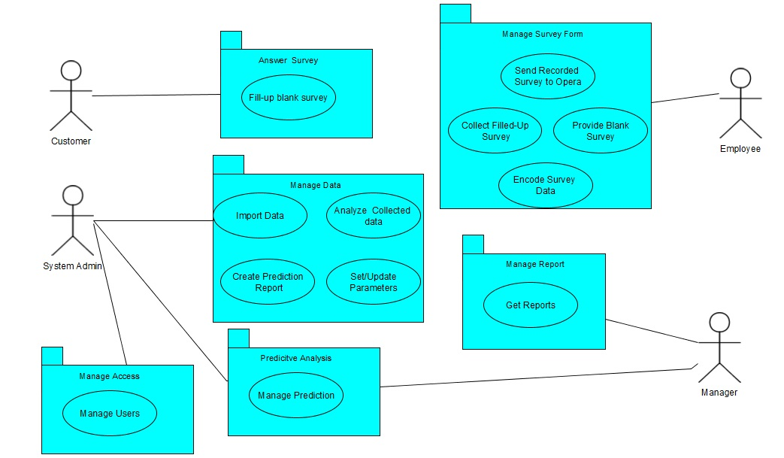

**3.8 Component Diagram**

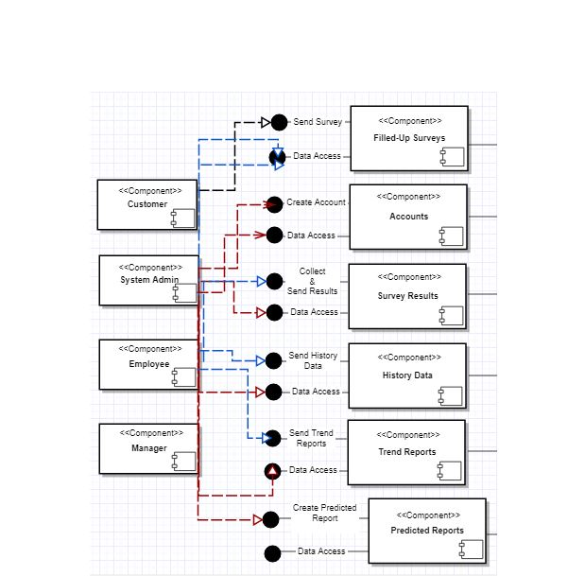

**3.9 Sequence Diagram**

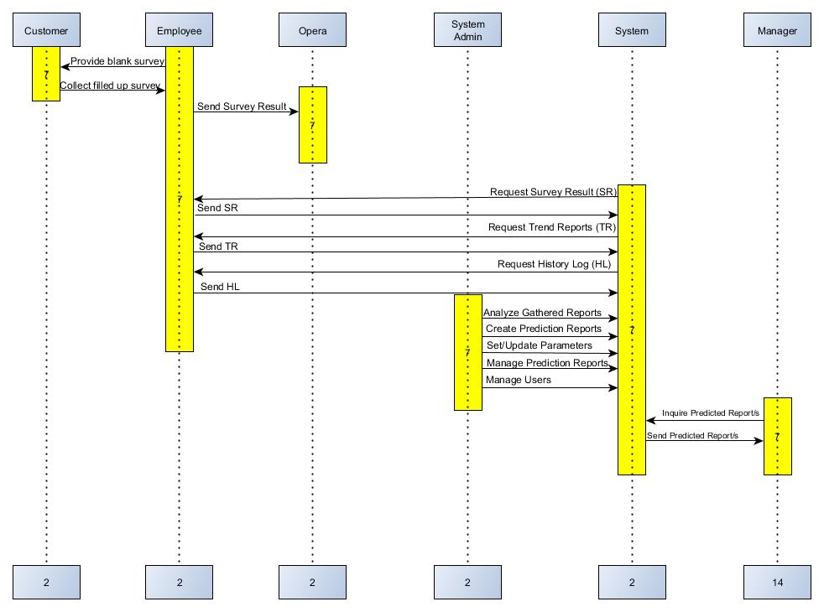

**3.10 Communication Diagram**

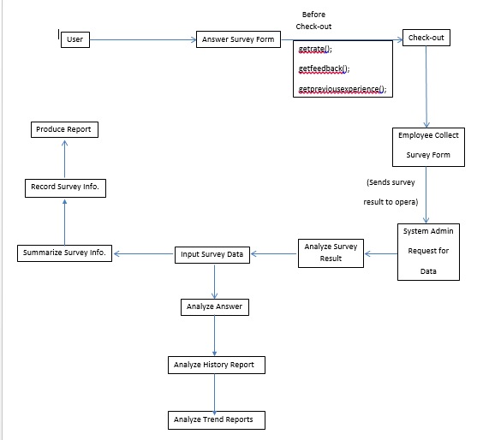

**3.11 Composite Diagram**

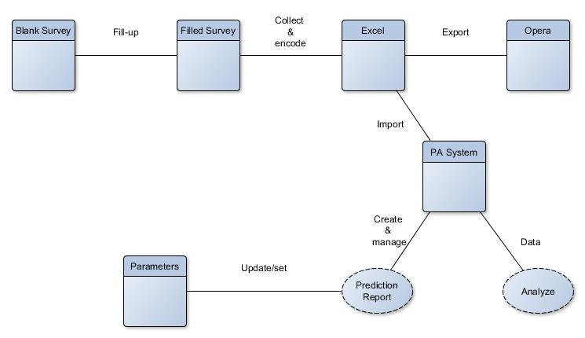

**3.12 Timing Diagram**

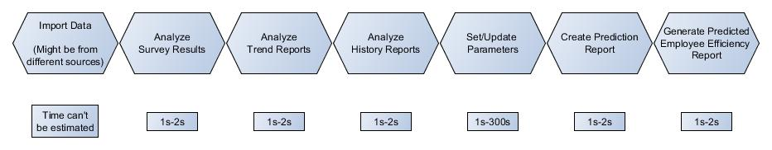

**3.13 Interaction Diagram**

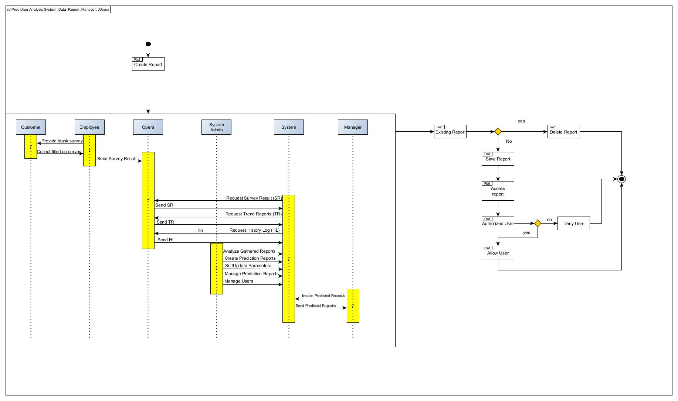

**3.14 Use Case Full Description**

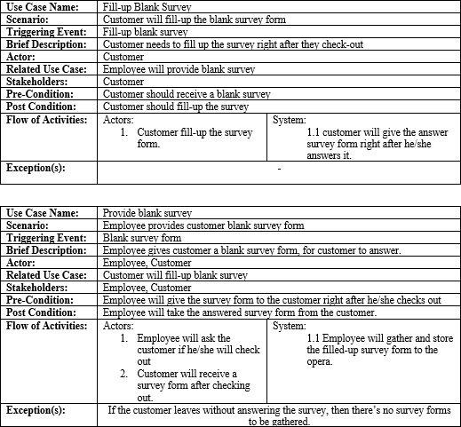

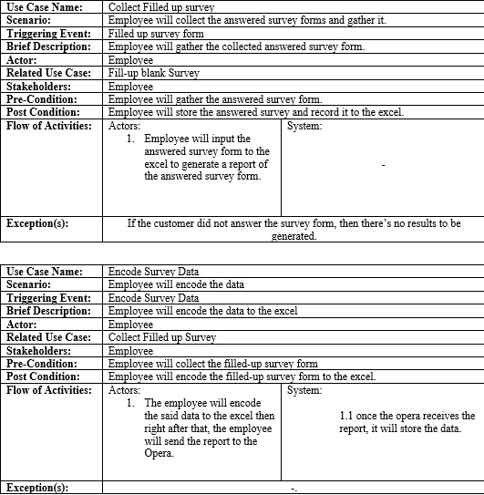

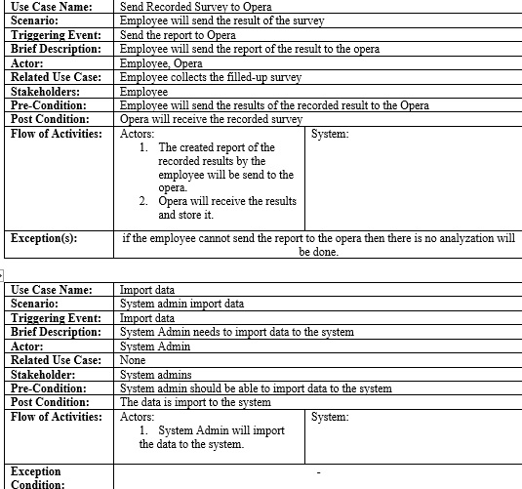

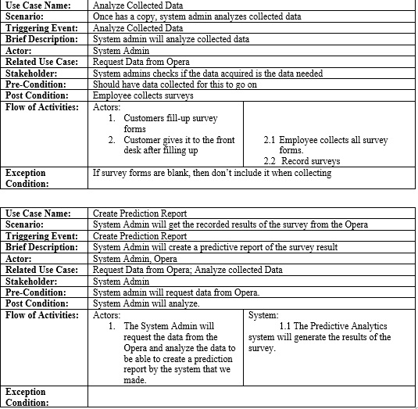

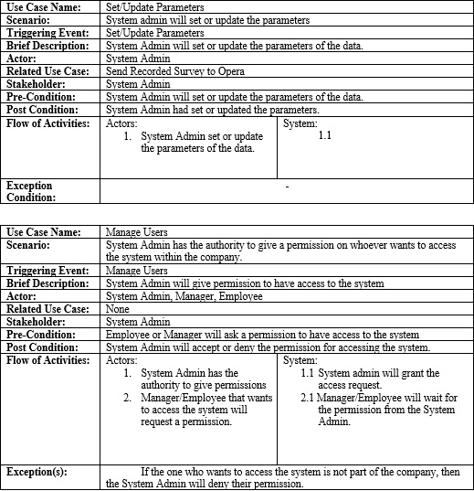

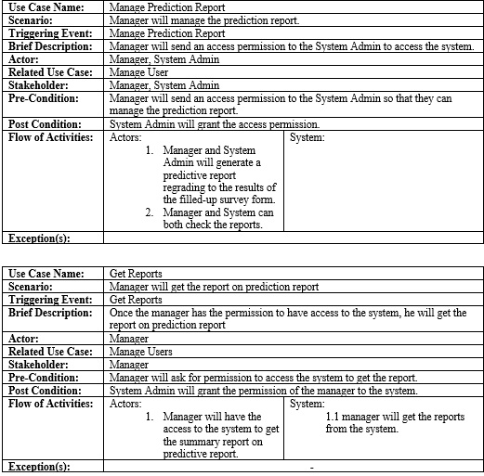

## IV. References